Locus

Definition
# Source: AI Source: Provided by: [Data Path: Persons Table -> ID Column: 1, Name_En Column: Motasem Essam] -> From: [ChatGPT] on [7/25/2026]
A locus is the set of all points that satisfy a specified geometric condition or rule.
The plural of locus is:
$$\boxed{\text{Loci}}$$
A locus is therefore a geometric set defined by a condition such as:
- being a fixed distance from a point
- being equally distant from two points
- being equally distant from two lines
- having a fixed distance from a line
- forming a fixed angle
- satisfying a distance relationship
- satisfying a geometric equation
The fundamental idea is:
$$\boxed{\text{Geometric Condition}→\text{Set of All Points}→\text{Locus}}$$
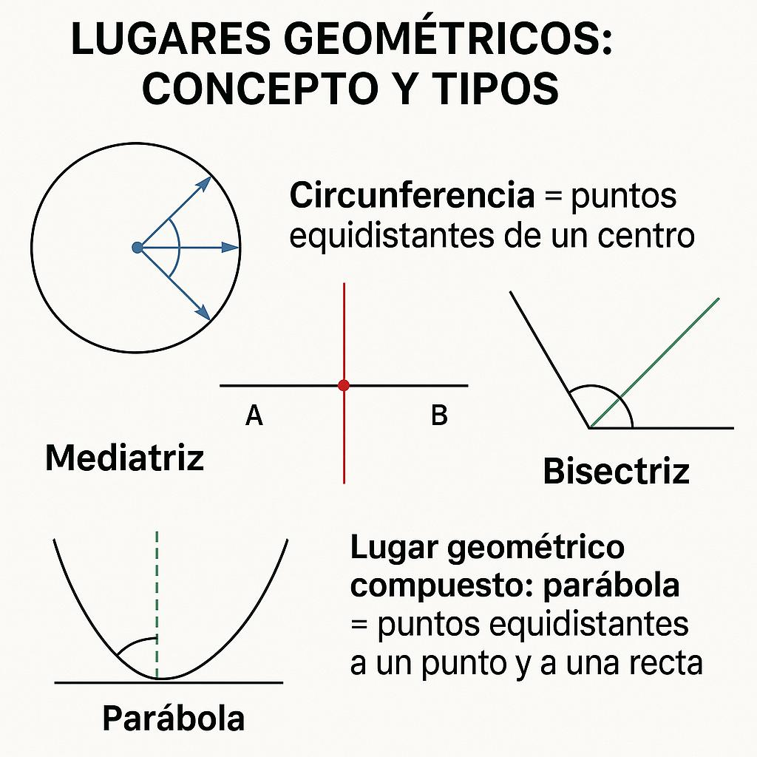
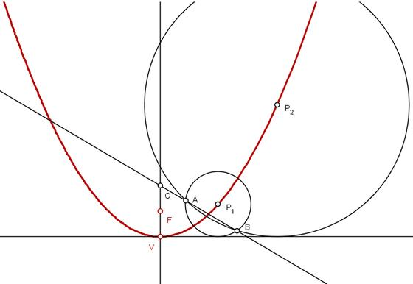
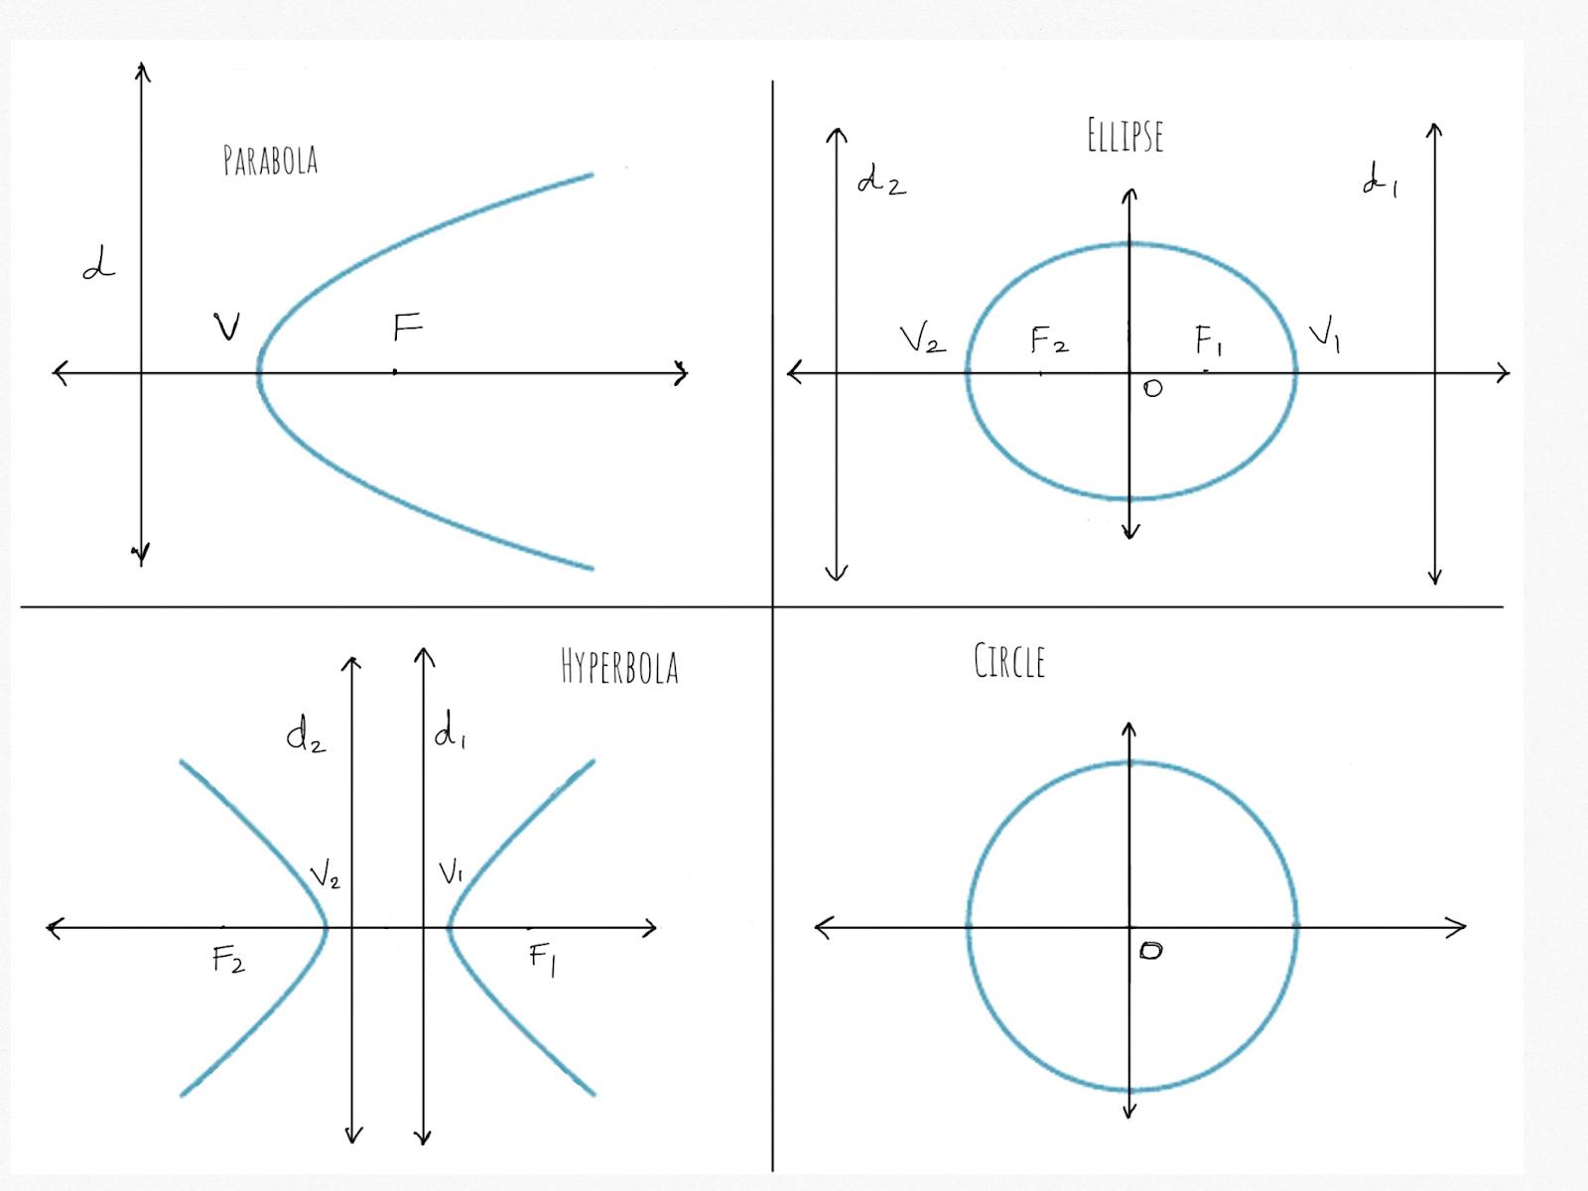
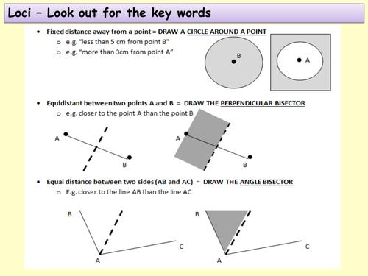
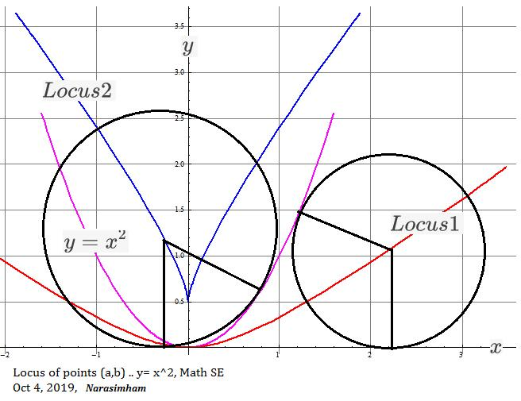
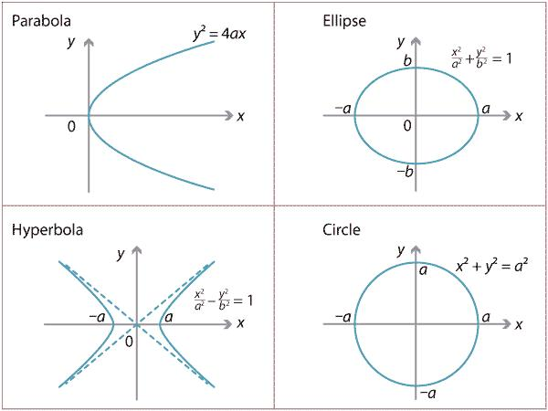

Simple Definition
# Source: AI Source: Provided by: [Data Path: Persons Table -> ID Column: 1, Name_En Column: Motasem Essam] -> From: [ChatGPT] on [7/25/2026]
A locus is the path or set of all points that satisfy a particular geometric condition.
For example:
The locus of all points exactly $5$cm from a fixed point $O$is a circle centered at $O$with radius $5$cm.
$$\boxed{OP=5}$$

Fundamental Concept
# Source: AI Source: Provided by: [Data Path: Persons Table -> ID Column: 1, Name_En Column: Motasem Essam] -> From: [ChatGPT] on [7/25/2026]
A locus problem normally contains:
- a moving point
- one or more fixed objects
- a condition that the moving point must satisfy
- the complete set of points satisfying that condition.
For example:
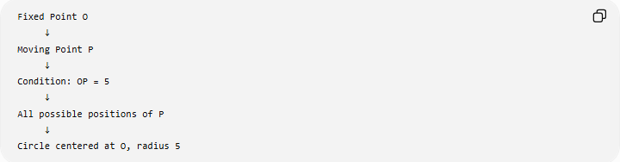
Fixed Point O
↓
Moving Point P
↓
Condition: OP = 5
↓
All possible positions of P
↓
Circle centered at O, radius 5
The important word is all.
A single point satisfying the condition is not the locus. The locus consists of every possible point satisfying it.

Main Types of Loci
# Source: AI Source: Provided by: [Data Path: Persons Table -> ID Column: 1, Name_En Column: Motasem Essam] -> From: [ChatGPT] on [7/25/2026]
A practical classification is:
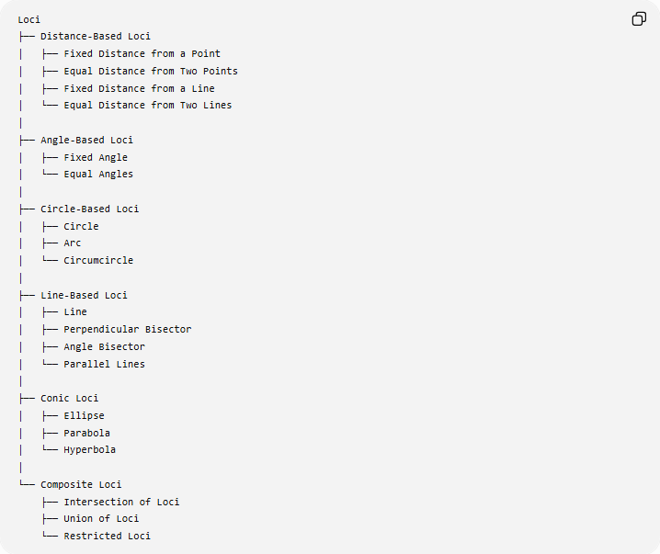
Loci
├── Distance-Based Loci
│ ├── Fixed Distance from a Point
│ ├── Equal Distance from Two Points
│ ├── Fixed Distance from a Line
│ └── Equal Distance from Two Lines
│
├── Angle-Based Loci
│ ├── Fixed Angle
│ └── Equal Angles
│
├── Circle-Based Loci
│ ├── Circle
│ ├── Arc
│ └── Circumcircle
│
├── Line-Based Loci
│ ├── Line
│ ├── Perpendicular Bisector
│ ├── Angle Bisector
│ └── Parallel Lines
│
├── Conic Loci
│ ├── Ellipse
│ ├── Parabola
│ └── Hyperbola
│
└── Composite Loci
├── Intersection of Loci
├── Union of Loci
└── Restricted Loci
This is a practical organizational classification; different textbooks may organize loci differently.

Locus of Points at a Fixed Distance from a Point
# Source: AI Source: Provided by: [Data Path: Persons Table -> ID Column: 1, Name_En Column: Motasem Essam] -> From: [ChatGPT] on [7/25/2026]
Definition
The locus of all points at a fixed distance $r$from a fixed point $O$is a circle centered at $O$.
The condition is:
$$\boxed{OP=r}$$
Example
Find the locus of all points $P$such that:
$$OP=4\text{ cm}$$
where $O$is fixed.
The answer is:
$$\boxed{\text{A circle centered at }O\text{ with radius }4\text{ cm}}$$
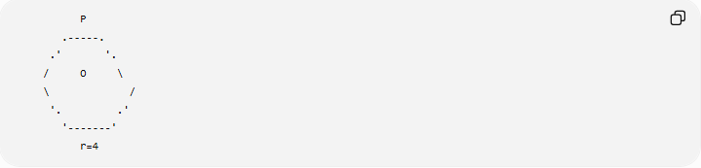
P
.-----.
.' '.
/ O \
\ /
'. .'
'-------'
r=4

Locus of Points Equidistant from Two Points
# Source: AI Source: Provided by: [Data Path: Persons Table -> ID Column: 1, Name_En Column: Motasem Essam] -> From: [ChatGPT] on [7/25/2026]
Definition
The locus of all points that are equally distant from two fixed points $A$and $B$is the perpendicular bisector of $\overset{‾}{AB}$.
The condition is:
$$\boxed{PA=PB}$$
Therefore:
$$\boxed{PA=PB ⟺ P\text{ lies on the perpendicular bisector of }AB}$$
Example
Given:
$$A B$$
Every point $P$satisfying:
$$PA=PB$$
lies on the perpendicular bisector.
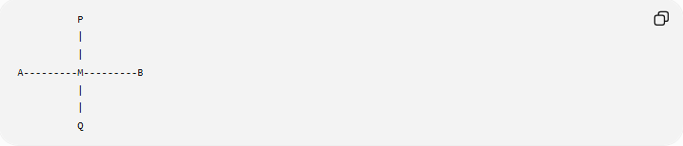
P
|
|
A---------M---------B
|
|
Q
Here:
$$AM=MB$$
and:
$$PQ⊥AB$$
Every point on $PQ$is equally distant from $A$and $B$.

Locus of Points Equidistant from Two Lines
# Source: AI Source: Provided by: [Data Path: Persons Table -> ID Column: 1, Name_En Column: Motasem Essam] -> From: [ChatGPT] on [7/25/2026]
Definition
The locus of points that are equally distant from two intersecting lines is formed by their angle bisectors.
If lines $l_{1}$and $l_{2}$intersect at $O$, then points on the angle bisectors satisfy:
$$\boxed{d\left(P , l_{1}\right)=d\left(P , l_{2}\right)}$$
There are generally two perpendicular angle bisectors:
- internal angle bisector
- external angle bisector
Example
If two lines form four angles, the points equally distant from both lines lie on the two angle-bisector lines.
Thus:
$$\boxed{\text{Equal distance from two intersecting lines}→\text{Angle Bisectors}}$$

Locus at a Fixed Distance from a Line
# Source: AI Source: Provided by: [Data Path: Persons Table -> ID Column: 1, Name_En Column: Motasem Essam] -> From: [ChatGPT] on [7/25/2026]
Definition
The locus of points at a fixed perpendicular distance $d$from a given line is generally two parallel lines, one on each side of the original line.
Given line $l$:
$$d\left(P , l\right)=d$$
produces:
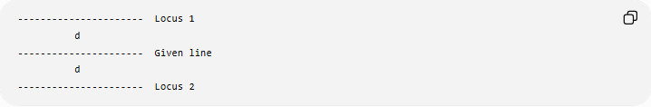
---------------------- Locus 1
d
---------------------- Given line
d
---------------------- Locus 2
Example
The locus of all points $3$cm from line $l$consists of two lines parallel to $l$, each $3$cm from it.
$$\boxed{d\left(P , l\right)=3}$$

Locus of Points on a Fixed Line
# Source: AI Source: Provided by: [Data Path: Persons Table -> ID Column: 1, Name_En Column: Motasem Essam] -> From: [ChatGPT] on [7/25/2026]
If a point $P$is required to lie on a given line $l$, then the locus is simply:
$$\boxed{l}$$
Example
If:
$$P∈l$$
then every point of $l$satisfies the condition.
Therefore:
$$\boxed{\text{Locus}=l}$$

Locus of Points on a Fixed Circle
# Source: AI Source: Provided by: [Data Path: Persons Table -> ID Column: 1, Name_En Column: Motasem Essam] -> From: [ChatGPT] on [7/25/2026]
If a point $P$must remain on a circle centered at $O$with radius $r$, then:
$$\boxed{OP=r}$$
and the locus is the circle:
$$\boxed{{\left(x-h\right)}^{2}+{\left(y-k\right)}^{2}=r^{2}}$$
where $O=\left(h , k\right)$.

Locus of Points Inside or Outside a Circle
# Source: AI Source: Provided by: [Data Path: Persons Table -> ID Column: 1, Name_En Column: Motasem Essam] -> From: [ChatGPT] on [7/25/2026]
Loci can also be defined using inequalities.
Inside a circle
$$\boxed{OP<r}$$
This describes the interior of the circle.
On the circle
$$\boxed{OP=r}$$
This describes the circumference.
Outside the circle
$$\boxed{OP>r}$$
This describes the exterior.
For a closed disk:
$$\boxed{OP≤r}$$

Parabola as a Locus
# Source: AI Source: Provided by: [Data Path: Persons Table -> ID Column: 1, Name_En Column: Motasem Essam] -> From: [ChatGPT] on [7/25/2026]
A parabola is a locus defined by a distance equality.
It is the set of all points $P$that are equally distant from:
- a fixed point called the focus
- a fixed line called the directrix.
Therefore:
$$\boxed{PF=d\left(P , l\right)}$$
where:
- $F$= focus
- $l$= directrix.
Example
If $F$is the focus and $l$is the directrix, every point $P$satisfying:
$$PF=d\left(P , l\right)$$
belongs to the parabola.
Thus:
$$\boxed{\text{Parabola}=\text{Equal-distance locus of a point and a line}}$$

Ellipse as a Locus
# Source: AI Source: Provided by: [Data Path: Persons Table -> ID Column: 1, Name_En Column: Motasem Essam] -> From: [ChatGPT] on [7/25/2026]
An ellipse is a locus defined using two fixed points called foci.
For every point $P$on the ellipse:
$$\boxed{PF_{1}+PF_{2}=2a}$$
where $F_{1},F_{2}$are the two foci and $2a$is the major-axis length.
Example
If:
$$PF_{1}+PF_{2}=20$$
for every point $P$, then the locus is an ellipse with:
$$2a=20$$
so:
$$a=10$$
Therefore:
$$\boxed{\text{Ellipse}=\text{Constant-sum distance locus}}$$

Hyperbola as a Locus
# Source: AI Source: Provided by: [Data Path: Persons Table -> ID Column: 1, Name_En Column: Motasem Essam] -> From: [ChatGPT] on [7/25/2026]
A hyperbola is a locus defined using two fixed points called foci.
For every point $P$:
$$\boxed{∣PF_{1}-PF_{2}∣=2a}$$
The absolute difference between the distances to the two foci is constant.
Therefore:
$$\boxed{\text{Hyperbola}=\text{Constant-difference distance locus}}$$
Example
If:
$$∣PF_{1}-PF_{2}∣=8$$
for every point $P$, then the resulting locus is a hyperbola with:
$$2a=8$$
and:
$$a=4$$

Conic Loci
# Source: AI Source: Provided by: [Data Path: Persons Table -> ID Column: 1, Name_En Column: Motasem Essam] -> From: [ChatGPT] on [7/25/2026]
The three major non-degenerate conics can be described through locus definitions.
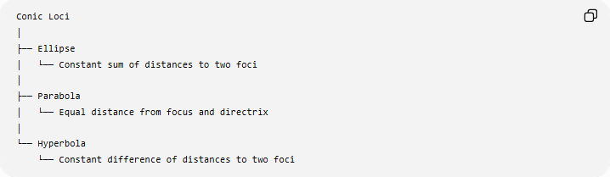
Conic Loci
│
├── Ellipse
│ └── Constant sum of distances to two foci
│
├── Parabola
│ └── Equal distance from focus and directrix
│
└── Hyperbola
└── Constant difference of distances to two foci
Their defining relationships are:
Ellipse
$$\boxed{PF_{1}+PF_{2}=2a}$$
Parabola
$$\boxed{PF=d\left(P , l\right)}$$
Hyperbola
$$\boxed{∣PF_{1}-PF_{2}∣=2a}$$

Locus of Points Forming a Fixed Angle
# Source: AI Source: Provided by: [Data Path: Persons Table -> ID Column: 1, Name_En Column: Motasem Essam] -> From: [ChatGPT] on [7/25/2026]
A more advanced locus is obtained when a point $P$must see a fixed segment $AB$under a constant angle:
$$\boxed{∠APB=θ}$$
For a fixed segment $AB$and a fixed nonzero angle $θ$, the locus generally consists of arcs of circles through $A$and $B$, with appropriate restrictions depending on the angle and side of $AB$.
Example
If:
$$AB=10$$
and:
$$∠APB={60}^{∘}$$
then $P$moves along appropriate circular arcs through $A$and $B$.
This is connected to the Inscribed Angle Theorem.

Circumcircle as a Locus
# Source: AI Source: Provided by: [Data Path: Persons Table -> ID Column: 1, Name_En Column: Motasem Essam] -> From: [ChatGPT] on [7/25/2026]
Consider a fixed triangle $ABC$.
The circumcircle is the locus of points that are at the same distance from the circumcenter $O$:
$$\boxed{PA=PB=PC}$$
More fundamentally, the circumcenter is obtained from the intersection of the perpendicular bisectors:
$$PA=PB$$
and:
$$PA=PC$$
Thus:
$$\boxed{\text{Circumcenter}=\text{Intersection of perpendicular-bisector loci}}$$

Locus and Perpendicular Bisector
# Source: AI Source: Provided by: [Data Path: Persons Table -> ID Column: 1, Name_En Column: Motasem Essam] -> From: [ChatGPT] on [7/25/2026]
This is one of the most important locus relationships in elementary geometry.
Given two fixed points $A$and $B$:
$$\boxed{PA=PB}$$
is equivalent to:
$$\boxed{P\text{ lies on the perpendicular bisector of }AB}$$
This is a biconditional relationship:
$$\boxed{PA=PB ⟺ P\text{ is on the perpendicular bisector of }AB}$$
It has two directions:
Forward
If:
$$PA=PB$$
then $P$lies on the perpendicular bisector.
Converse
If $P$lies on the perpendicular bisector, then:
$$PA=PB$$

Locus and Angle Bisector
# Source: AI Source: Provided by: [Data Path: Persons Table -> ID Column: 1, Name_En Column: Motasem Essam] -> From: [ChatGPT] on [7/25/2026]
There is a similar relationship for two intersecting lines.
If point $P$has equal perpendicular distances to the two lines:
$$d\left(P , l_{1}\right)=d\left(P , l_{2}\right)$$
then $P$lies on an angle bisector of those lines.
Conversely, every point on an angle bisector has equal perpendicular distances from the two lines.
Therefore:
$$\boxed{d\left(P , l_{1}\right)=d\left(P , l_{2}\right) ⟺ P\text{ lies on an angle bisector}}$$

Intersection of Loci
# Source: AI Source: Provided by: [Data Path: Persons Table -> ID Column: 1, Name_En Column: Motasem Essam] -> From: [ChatGPT] on [7/25/2026]
Some locus problems require satisfying more than one condition simultaneously.
Suppose:
$$PA=PB$$
and:
$$PA=PC$$
Then $P$must lie on:
- the perpendicular bisector of $AB$
- the perpendicular bisector of $AC$
Therefore $P$is their intersection.
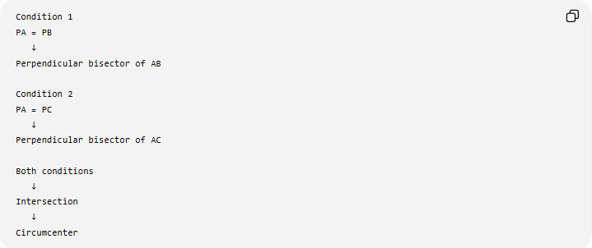
Condition 1
PA = PB
↓
Perpendicular bisector of AB

Condition 2
PA = PC
↓
Perpendicular bisector of AC

Both conditions
↓
Intersection
↓
Circumcenter
This is a fundamental method for solving construction and locus problems.

Union of Loci
# Source: AI Source: Provided by: [Data Path: Persons Table -> ID Column: 1, Name_En Column: Motasem Essam] -> From: [ChatGPT] on [7/25/2026]
Sometimes a condition can be satisfied by points belonging to more than one separate locus.
For example, points at a fixed distance $d$from a line form two parallel lines:
$$\boxed{L_{1}∪L_{2}}$$
The symbol $∪$means union.
Thus a locus does not always have to be a single connected curve.

Restricted Loci
# Source: AI Source: Provided by: [Data Path: Persons Table -> ID Column: 1, Name_En Column: Motasem Essam] -> From: [ChatGPT] on [7/25/2026]
A geometric condition may produce an entire line or circle mathematically, but additional restrictions can reduce the actual locus.
For example:
$P$lies on segment $AB$and satisfies a particular distance condition.
The locus is then only the part of the relevant geometric locus that lies on $\overset{‾}{AB}$.
Therefore:
$$\boxed{\text{Complete Locus}+\text{Geometric Restrictions}→\text{Restricted Locus}}$$

Loci in Coordinate Geometry
# Source: AI Source: Provided by: [Data Path: Persons Table -> ID Column: 1, Name_En Column: Motasem Essam] -> From: [ChatGPT] on [7/25/2026]
A locus can be represented algebraically.
Suppose $P=\left(x , y\right)$and the fixed point is:
$$O=\left(h , k\right)$$
If:
$$OP=r$$
then by the distance formula:
$$\sqrt{{\left(x-h\right)}^{2}+{\left(y-k\right)}^{2}}=r$$
Squaring:
$$\boxed{{\left(x-h\right)}^{2}+{\left(y-k\right)}^{2}=r^{2}}$$
This is the equation of a circle.
Thus:
$$\boxed{\text{Geometric Condition}↔\text{Locus Equation}}$$

Example: Coordinate Locus
# Source: AI Source: Provided by: [Data Path: Persons Table -> ID Column: 1, Name_En Column: Motasem Essam] -> From: [ChatGPT] on [7/25/2026]
Find the locus of all points $P=\left(x , y\right)$that are $5$units from:
$$O=\left(2 , 3\right)$$
The condition is:
$$OP=5$$
Using the distance formula:
$$\sqrt{{\left(x-2\right)}^{2}+{\left(y-3\right)}^{2}}=5$$
Therefore:
$$\boxed{{\left(x-2\right)}^{2}+{\left(y-3\right)}^{2}=25}$$
The locus is a circle centered at:
$$\boxed{\left(2 , 3\right)}$$
with radius:
$$\boxed{5}$$

Locus in Three Dimensions
# Source: AI Source: Provided by: [Data Path: Persons Table -> ID Column: 1, Name_En Column: Motasem Essam] -> From: [ChatGPT] on [7/25/2026]
The concept of locus is not limited to the plane.
In three-dimensional geometry, a locus can be a surface or another three-dimensional set.
Example
The locus of all points at distance $r$from a fixed point $O$is a sphere:
$$\boxed{{\left(x-h\right)}^{2}+{\left(y-k\right)}^{2}+{\left(z-l\right)}^{2}=r^{2}}$$
where:
$$O=\left(h , k , l\right).$$
So:
$$\boxed{\text{2D fixed-distance locus}→\text{Circle}}$$
while:
$$\boxed{\text{3D fixed-distance locus}→\text{Sphere}}$$

Locus Construction
# Source: AI Source: Provided by: [Data Path: Persons Table -> ID Column: 1, Name_En Column: Motasem Essam] -> From: [ChatGPT] on [7/25/2026]
Locus problems are closely connected to geometric construction.
A typical construction process is:
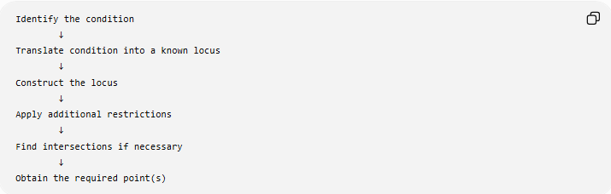
Identify the condition
↓
Translate condition into a known locus
↓
Construct the locus
↓
Apply additional restrictions
↓
Find intersections if necessary
↓
Obtain the required point(s)
Example
Suppose $P$must satisfy:
$$PA=PB$$
and:
$$PC=4$$
Then:
- Construct the perpendicular bisector of $AB$.
- Construct the circle centered at $C$with radius $4$.
- Find their intersection points.
- Those intersection points satisfy both conditions.

Locus vs Path
# Source: AI Source: Provided by: [Data Path: Persons Table -> ID Column: 1, Name_En Column: Motasem Essam] -> From: [ChatGPT] on [7/25/2026]
These terms are related but should not always be treated as identical.
Path
Usually emphasizes the route followed by a moving point.
Locus
Emphasizes the complete set of points satisfying a mathematical condition.
For example:
A point moves so that its distance from $O$remains $5$cm.
Its path is a circle, and its locus is the circle defined by:
$$OP=5$$
In elementary geometry, the terms are sometimes used interchangeably, but locus is the more precise mathematical term when a defining condition is involved.

Locus vs Geometric Construction
# Source: AI Source: Provided by: [Data Path: Persons Table -> ID Column: 1, Name_En Column: Motasem Essam] -> From: [ChatGPT] on [7/25/2026]
They are related but different.
Locus
Answers:
Which points satisfy the condition?
Construction
Answers:
How can we construct those points or the corresponding figure?
For example:
$$PA=PB$$
gives the locus:
$$\boxed{\text{Perpendicular bisector of }AB}$$
Constructing that perpendicular bisector using a compass and straightedge is the construction.

Locus vs Equation
# Source: AI Source: Provided by: [Data Path: Persons Table -> ID Column: 1, Name_En Column: Motasem Essam] -> From: [ChatGPT] on [7/25/2026]
A locus can have both a geometric and algebraic description.
For example:
Geometric
All points $P$at distance $r$from $O$.
Algebraic
$${\left(x-h\right)}^{2}+{\left(y-k\right)}^{2}=r^{2}$$
These describe the same locus.
Thus:
$$\boxed{\text{Geometric Condition}↔\text{Geometric Locus}↔\text{Equation}}$$

Common Locus Relationships
# Source: AI Source: Provided by: [Data Path: Persons Table -> ID Column: 1, Name_En Column: Motasem Essam] -> From: [ChatGPT] on [7/25/2026]
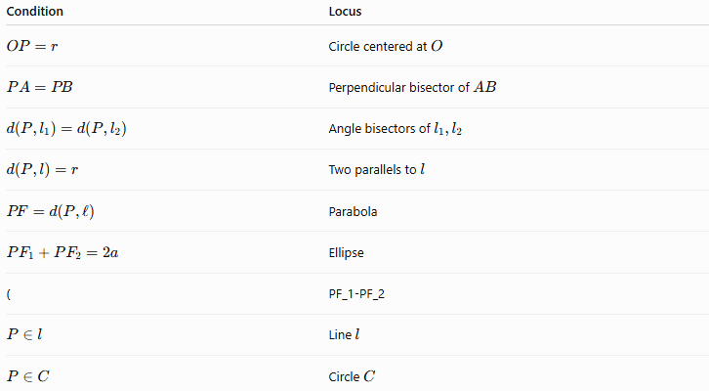
Condition | Locus
$$OP=r$$ | Circle centered at $O$
$$PA=PB$$ | Perpendicular bisector of $AB$
$$d\left(P , l_{1}\right)=d\left(P , l_{2}\right)$$ | Angle bisectors of $l_{1},l_{2}$
$$d\left(P , l\right)=r$$ | Two parallels to $l$
$$PF=d\left(P , l\right)$$ | Parabola
$$PF_{1}+PF_{2}=2a$$ | Ellipse
( | PF_1-PF_2
$$P∈l$$ | Line $l$
$$P∈C$$ | Circle $C$

Locus in Geometric Proofs
# Source: AI Source: Provided by: [Data Path: Persons Table -> ID Column: 1, Name_En Column: Motasem Essam] -> From: [ChatGPT] on [7/25/2026]
Loci are also useful in proving geometric statements.
For example, to prove that a point is equidistant from two points, one can show that the point lies on their perpendicular bisector.
If:
$$P∈\text{Perpendicular Bisector of }AB$$
then:
$$\boxed{PA=PB}$$
This converts a geometric location into a geometric equality.
Similarly:
$$P∈\text{Angle Bisector}$$
can establish equal perpendicular distances to the two sides of the angle.

Important Distinction: Locus Is a Set
# Source: AI Source: Provided by: [Data Path: Persons Table -> ID Column: 1, Name_En Column: Motasem Essam] -> From: [ChatGPT] on [7/25/2026]
A locus is not necessarily:
- a single point
- a line only
- a circle only
- a physical path only.
It can be:
- a point
- a line
- a circle
- an arc
- two parallel lines
- two angle bisectors
- a conic
- several disconnected curves
- a region when inequalities are used.
The actual form depends entirely on the defining condition.

Classification Summary
# Source: AI Source: Provided by: [Data Path: Persons Table -> ID Column: 1, Name_En Column: Motasem Essam] -> From: [ChatGPT] on [7/25/2026]
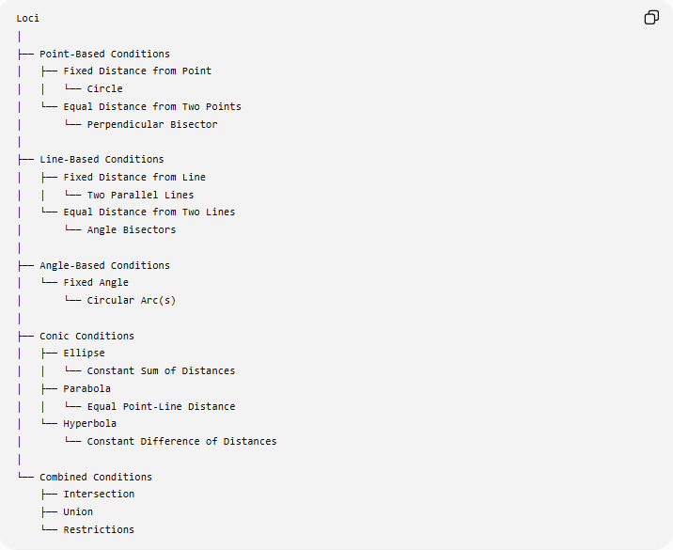
Loci
│
├── Point-Based Conditions
│ ├── Fixed Distance from Point
│ │ └── Circle
│ └── Equal Distance from Two Points
│ └── Perpendicular Bisector
│
├── Line-Based Conditions
│ ├── Fixed Distance from Line
│ │ └── Two Parallel Lines
│ └── Equal Distance from Two Lines
│ └── Angle Bisectors
│
├── Angle-Based Conditions
│ └── Fixed Angle
│ └── Circular Arc(s)
│
├── Conic Conditions
│ ├── Ellipse
│ │ └── Constant Sum of Distances
│ ├── Parabola
│ │ └── Equal Point-Line Distance
│ └── Hyperbola
│ └── Constant Difference of Distances
│
└── Combined Conditions
├── Intersection
├── Union
└── Restrictions

Key Points
# Source: AI Source: Provided by: [Data Path: Persons Table -> ID Column: 1, Name_En Column: Motasem Essam] -> From: [ChatGPT] on [7/25/2026]
- Locus means the set of all points satisfying a specified condition.
- The plural is:
$$\boxed{\text{loci}}$$
- A fixed distance from a point gives a circle:
$$\boxed{OP=r}$$
- Equal distance from two points gives a perpendicular bisector:
$$\boxed{PA=PB}$$
- Equal distance from two intersecting lines gives angle bisectors.
- A fixed distance from a line gives two parallel lines.
- A parabola is defined by equal distance from a focus and directrix:
$$\boxed{PF=d\left(P , l\right)}$$
- An ellipse is defined by a constant sum:
$$\boxed{PF_{1}+PF_{2}=2a}$$
- A hyperbola is defined by a constant difference:
$$\boxed{∣PF_{1}-PF_{2}∣=2a}$$
- Multiple conditions can be solved by intersecting their loci.
- Loci can be represented geometrically, algebraically, or parametrically.
- Locus problems are closely connected to geometric construction, coordinate geometry, transformations, distance geometry, and conic sections.

Conclusion
# Source: AI Source: Provided by: [Data Path: Persons Table -> ID Column: 1, Name_En Column: Motasem Essam] -> From: [ChatGPT] on [7/25/2026]
Loci are fundamental geometric sets defined by conditions on points. The central principle is:
$$\boxed{\text{Condition on a Point}→\text{All Points Satisfying the Condition}→\text{Locus}}$$
Some of the most important examples are:
$$\boxed{OP=r→\text{Circle}} \\ \boxed{PA=PB→\text{Perpendicular Bisector}} \\ \boxed{d\left(P , l_{1}\right)=d\left(P , l_{2}\right)→\text{Angle Bisectors}} \\ \boxed{PF=d\left(P , l\right)→\text{Parabola}} \\ \boxed{PF_{1}+PF_{2}=\text{constant}→\text{Ellipse}} \\ \boxed{∣PF_{1}-PF_{2}∣=\text{constant}→\text{Hyperbola}}$$
Thus, locus geometry provides a direct connection between geometric conditions and the shapes formed by all points satisfying those conditions.

